Bio Coursework

I set set cartoon_fancy_helices, 1 as it made it clearer to see the structural alignment

1THF: Chain D

1. Fold: [TIM beta/alpha-barrel](http://scop.mrc-lmb.cam.ac.uk/scop/data/scop.b.d.b.html) [51350]
2. Superfamily: [Ribulose-phoshate binding barrel](http://scop.mrc-lmb.cam.ac.uk/scop/data/scop.b.d.b.c.html) [51366]
3. Family: [Histidine biosynthesis enzymes](http://scop.mrc-lmb.cam.ac.uk/scop/data/scop.b.d.b.c.b.html) [51367]
4. Protein: Cyclase subunit (or domain) of imidazoleglycerolphosphate synthase HisF [51370]
5. Species: [Thermotoga maritima](http://scop.mrc-lmb.cam.ac.uk/scop/data/scop.b.d.b.c.b.d.html)[[TaxId: 2336]](http://www.ncbi.nih.gov/Taxonomy/Browser/wwwtax.cgi?id=2336&lvl=0) [51371]

1VZW: [region a:2-240](http://scop.mrc-lmb.cam.ac.uk/scop/pdb.cgi?sid=d1vzwa1&disp=scop) [120553]

1. Fold: [TIM beta/alpha-barrel](http://scop.mrc-lmb.cam.ac.uk/scop/data/scop.b.d.b.html) [51350]
2. Superfamily: [Ribulose-phoshate binding barrel](http://scop.mrc-lmb.cam.ac.uk/scop/data/scop.b.d.b.c.html) [51366]
3. Family: [Histidine biosynthesis enzymes](http://scop.mrc-lmb.cam.ac.uk/scop/data/scop.b.d.b.c.b.html) [51367]
4. Protein: Phosphoribosylformimino-5-aminoimidazole carboxamide ribotite isomerase HisA [51368]
5. Species: [Streptomyces coelicolor](http://scop.mrc-lmb.cam.ac.uk/scop/data/scop.b.d.b.c.b.c.html)[[TaxId: 1902]](http://www.ncbi.nih.gov/Taxonomy/Browser/wwwtax.cgi?id=1902&lvl=0) [141744]   
   *SQ*[*P16250*](http://www.uniprot.org/uniprot/P16250)*2-240*

1BDO

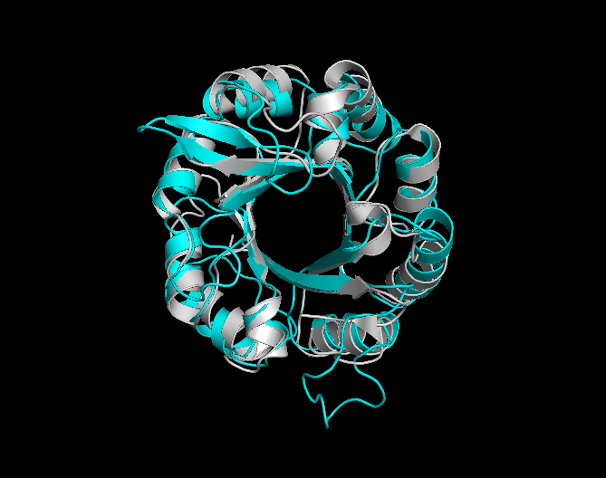

1THF vs 1VZW

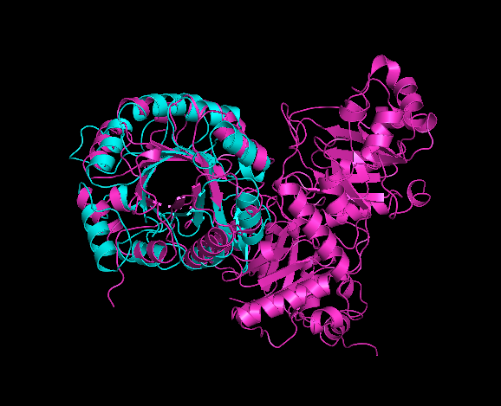

1THF vs 1RPX

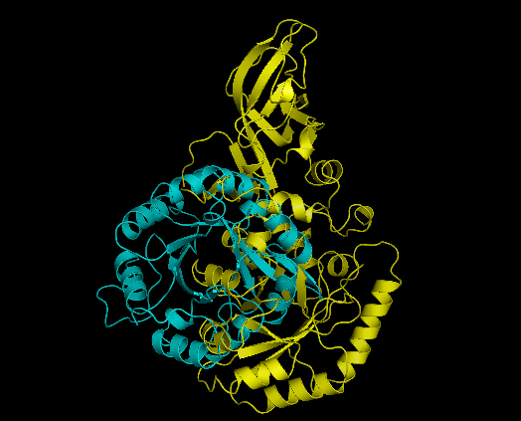

1THF vs 1BDO